

**FNDB020 Accounting**

**Student Workbook**

Lecture and Tutorial

# Week 8: Non-Current Assets

**Updated April 2016**

## FNDB020 Lecture Week 8: Non-Current Assets

**Definition of PPE**

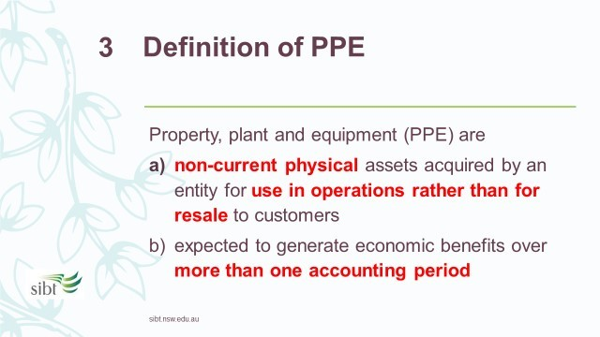

Property, plant and equipment (PPE) are:

1. non-current physical assets acquired by an entity for use in operations rather than for resale to customers
2. expected to generate economic benefits over more than one accounting period

Examples of PPE: land, buildings, machinery, motor vehicles, equipment

|  |  |
| --- | --- |
| **Exercise 8.1** | Definition of PPE |

Adele has the following items in her flower shop business. Which ones are PPE? For items which are not PPE, how do you categorise them?

|  |  |
| --- | --- |
| **Items** | **Category** |
| (a) The flower shop rented by Adele | Expense |
| (b) The fresh flowers in stock for resale | Inventory |
| (c) The laptop used by Adele to manage the business | PPE |
| (d) The fridge used to store the flowers overnight | PPE |
| (e) A bunch of flowers Adele uses to decorate her shop | Expense |
| (f) The CD player to play music for customers | PPE |
| (g) The display shelves in the shop | PPE |
| (h) The cash register | PPE |

Reasons:

1. (d) (f) (g) (h) are PPE for satisfying the definition of PPE.

(a) (b) (e) are not PPE for the following reasons.

1. The flower shop is not acquired by Adele therefore should not be listed as an asset of the business.
2. The flowers are inventory.
3. The fresh flowers for decoration do not benefit the business for more than an accounting period. It is treated as an expense.

**To record PPE on the balance sheet**

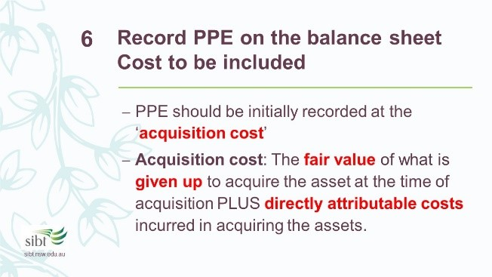

**A. Costs to be included:**

PPE should initially be recorded on the purchase date at the acquisition cost.

**Acquisition cost:** the amount of cash or cash equivalents paid or the fair value of what is given up to acquire an asset at the time of its acquisition PLUS directly attributable costs incurred in acquiring the assets.

**Fair value:** the price at which the asset can be exchanged between knowledgeable willing parties in an arm’s length transaction.

Note that we should measure the fair value of what is given up, not the fair value of the asset being acquired.

**Directly attributable costs:** any costs necessary to bring the asset to the location and condition ready for its intended use.

Examples of directly attributable costs: delivery costs, insurance while in transit, installation cost, assembly costs, cost of testing the asset, staff training, stamp duty.

**B.**

**Costs to be excluded**

**:**

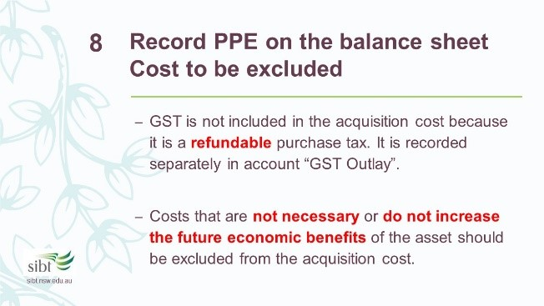

**GST** is not included in the acquisition cost of PPE because it is a refundable purchase tax. It is recorded separately in the GST Outlay account.

Costs that are not necessary or do not increase the future economic benefits of the asset should be excluded from the acquisition cost. Those costs should be recognised as expenses when they are incurred.

Example of costs to be excluded: the cost to repair the asset due to careless installation.

|  |  |
| --- | --- |
| **Exercise 8.2** | Acquisition cost of PPE |

Adele bought some display shelves for her flower shop and received the delivery on the 1 July 2016. Which of the following costs are included in the cost of acquisition of the display shelves?

|  |  |  |  |
| --- | --- | --- | --- |
| **Items** | **Amount paid** |  | **Acquisition cost (Y/N)?** |
| Purchase price of the display shelves  (exclude GST) |  | 1,500 | Yes |
| GST on purchase price |  | 150 | No |
| The delivery cost |  | 50 | Yes |
| GST on delivery cost |  | 5 | No |
| The installation cost |  | 150 | Yes |
| GST on installation cost |  | 15 | No |
| Insurance on the shelves while in transit |  | 30 | Yes |
| GST on insurance |  | 3 | No |
| Repairs for damage caused by careless installation |  | 40 | No |
| GST on repair |  | 4 | No |

Calculate the total acquisition cost of the display shelves:

Total acquisition cost =1,500+50+150+30=1730

Assume Adele paid the above costs by cash. Prepare the journal entries for the above transactions in the month of July 2016.

|  |  |  |  |
| --- | --- | --- | --- |
|  | **General Journ** | **al** |  |
| **Date** | **Details** | **Debits** | **Credits** |
| 1 Jul 16 | Display shelves | 1,730 |  |
|  | GST Outlays | 173 |  |
|  | Cash at bank |  | 1,903 |
|  | (Purchase display shelves) |  |  |
|  |  |  |  |
| 1 Jul 16 | Repairs expense | 40 |  |
|  | GST Outlays | 4 |  |
|  | Cash at bank |  | 44 |
|  | (record cost of repairs to shelves) |  |  |

**C.**

**Lump**

**sum acquisition**

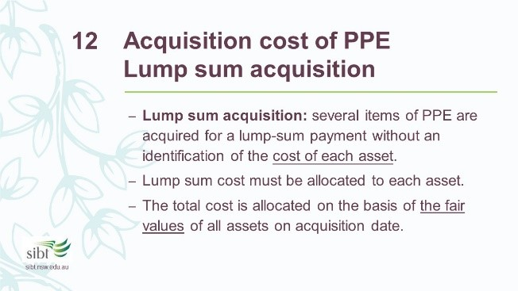

**Lump sum acquisition:** several items of PPE are acquired for a lump-sum payment without an identification of the cost of each asset.

The lump sum cost must be allocated to each asset because different depreciation rules may apply to different assets.

The lump sum cost is allocated on the basis of the fair values of all assets on acquisition date. The following formula is used to calculate the cost allocated to each asset:

fair value of specific asset

Cost allocated to each asset = total cost ×

total fair value

|  |  |
| --- | --- |
| **Exercise 10.3** | Lump Sum Acquisition |

On 2 July 2016, Adele purchased a cash register, a CD player and a laptop for a lump sum payment of 1,200 plus GST. The fair values of the items are assessed as follows. Please allocate the acquisition cost to each item.

|  |  |  |  |
| --- | --- | --- | --- |
| **Asset** | **Fair Value** | **Proportion** | **Cost allocated** |
| Cash register | 400 | 4/15*1,200 | 320 |
| CD player | 200 | 2/15*1,200 | 160 |
| Laptop | 900 | 9/15*1,200 | 720 |
| Total | **1,500** |  | 1,200 |

Assume Adele paid the full amount by cash. Prepare the journal entry for the purchase:

|  |  |  |  |
| --- | --- | --- | --- |
|  | **General Journ** | **al** |  |
| **Date** | **Details** | **Debits** | **Credits** |
| 02 Jul 16 | Cash register | 320 |  |
|  | CD player | 160 |  |
|  | Laptop | 720 |  |
|  | GST Outlay | 120 |  |
|  | Cash at bank |  | 1,320 |
|  | (To record purchase of assets) |  |  |

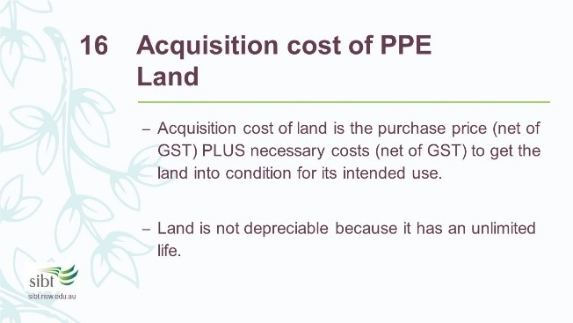

### D. Acquisition cost of land

Acquisition cost of land is the purchase price (net of GST) PLUS necessary costs (net of GST) to get the land into condition for its intended use.

Example: If the land contains a building that is to be demolished in order to construct a new building, the total purchase price plus the cost of removing the old building is included in the cost of the land. The cost of removing the old building is necessary to get the land ready for its intended use – to construct a new building.

Land is generally not depreciable because it has an unlimited life.

However, improvements made to land have limited lives and are properly depreciated. These items are not included in the acquisition cost of land and are charged to a separate account “land improvements”.

Examples: buildings, swimming pool, driveways, fences, parking lots and landscaping.

**Depreciation of PPE**

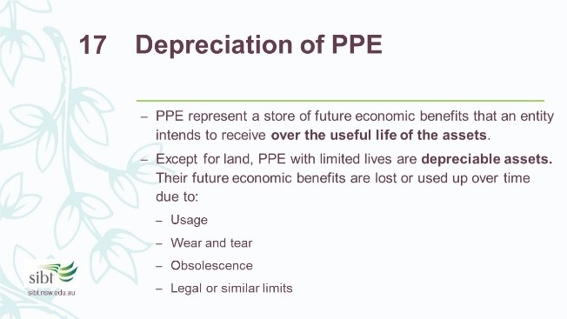

PPE represent a store of future economic benefits that an entity intends to receive over the useful life of the assets.

**Useful life:** the period over which an asset is expected to be available for use or the number of production or similar units expected to be obtained from the asset.

**Scrap value (Residual value):** the estimated amount that an entity could currently obtain from disposal of the asset at the end of its useful life.

Except for land, PPE with limited lives are depreciable assets. Their future economic benefits are lost or used up over time due to:

1. Usage:

The expected usage of the asset can be assessed referring to the asset’s expected output.

1. Wear and tear:

The physical damage of assets due to usage and cannot be restored by maintenance.

1. Obsolescence:
   1. Technical obsolescence due to technological improvements e.g. new models released
   2. The replaceable parts are no longer available for the asset
2. Legal or similar limits:

The limits on the use of an assets. E.g. the expiry dates of leases or licences.

**D**

**epreciation methods**

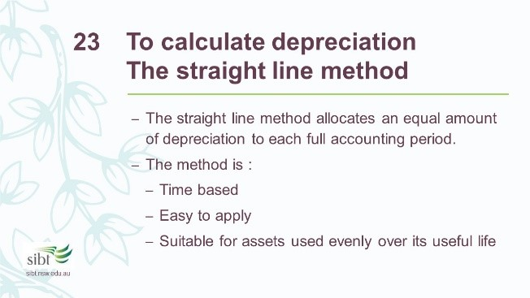

### A. The straight line method

cost−scrap value

Depreciation expense=

useful life in years

|  |  |
| --- | --- |
| **Exercise 8.4** | Depreciation Method 1 – Straight Line |

On 1 Oct 2016, Adele bought a ribbon printing machine for her flower shop. The acquisition cost of the machine is $960. She has decided to use the straight line method to calculate depreciation. It is assessed that the useful life of the machine is 5 years with $60 scrap value.

1. Calculate the depreciation expense per year:

|  |
| --- |
| Depreciation expense= !"#!!"=$180 per year ! |

Complete the depreciation schedule:

|  |  |  |  |  |
| --- | --- | --- | --- | --- |
|  | **Beginning carrying value** | **Depreciation** | **Year-end carrying value** | **Accumulated**  **Depreciation** |
| Year 1 ended 30/06/17 |  |  |  |  |
| Year 2 ended 30/06/18 |  |  |  |  |
| Year 3 ended 30/06/19 |  |  |  |  |
| Year 4 ended 30/06/20 |  |  |  |  |
| Year 5 ended 30/06/21 |  |  |  |  |
| Year 6 ended 30/06/22 |  |  |  |  |
| Total depreciation |  |  |  |  |

Note that for the first year, we should not recognise the full $180 depreciation expense because Adele only holds the asset for 9 months (1.10.16 - 30.6 17). The depreciation expense should be pro-rated.

For a similar reason, the depreciation expense for last year is also lower because the 5-year useful life ends in the middle of the accounting period.

1. Prepare the adjusting entry on the 30 Jun 2017:

|  |  |  |  |
| --- | --- | --- | --- |
|  | **General Journal** |  |  |
| **Date** | **Details** | **Debits** | **Credits** |
| 30 Jun 17 | Depreciation Expense – Equipment | 135 |  |
|  | Accumulated Depreciation –  Equipment |  | 135 |
|  | (To record depreciation expense) |  |  |

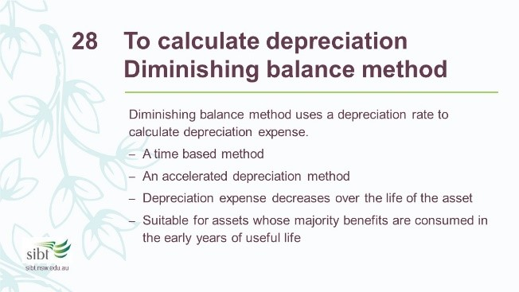

### B. The diminishing balance method

! scrap value

Depreciation rate =1−

cost

Depreciation expense= depreciation rate∗ Carrying value at the start of each period

Carrying value = cost − accumlated depreciation

|  |  |
| --- | --- |
| **Exercise 8.5** | Depreciation Method 2 – Diminishing Balance |

For the same ribbon printing machine, Adele has decided to use diminishing balance method to calculate depreciation. The useful life and the scrap value stay the same.

1. Calculate the depreciation rate:

|  |
| --- |
| Depreciation Rate =1− ! !" =43% (Approximately)  !"# |

1. Complete the depreciation schedule:

|  |  |  |  |  |
| --- | --- | --- | --- | --- |
|  | **Beginning carrying value** | **Depreciation** | **Year-end carrying value** | **Accumulated depreciation** |
| Year 1 ended 30/06/17 |  |  |  |  |
| Year 2 ended 30/06/18 |  |  |  |  |
| Year 3 ended 30/06/19 |  |  |  |  |
| Year 4 ended 30/06/20 |  |  |  |  |
| Year 5 ended 30/06/21 |  |  |  |  |
| Year 6 ended 30/06/22 |  |  |  |  |
| Total depreciation |  |  |  |  |

Note that the depreciation expense for the first year is pro-rated because Adele does not hold the asset for the whole year.

Also note that the depreciation expense for the last year is not calculated using the depreciation rate. It is calculated using the carrying value before depreciation in the last year, minus the scrap value.

Prepare the adjusting entry on the 30 Jun 2017:

|  |  |  |  |
| --- | --- | --- | --- |
|  | **General Journal** |  |  |
| **Date** | **Details** | **Debits** | **Credits** |
| 30 Jun 17 | Depreciation Expense – Equipment | 310 |  |
|  | Accumulated Depreciation –  Equipment |  | 310 |
|  | (To record depreciation expense) |  |  |

**C.**

**The units of production method**

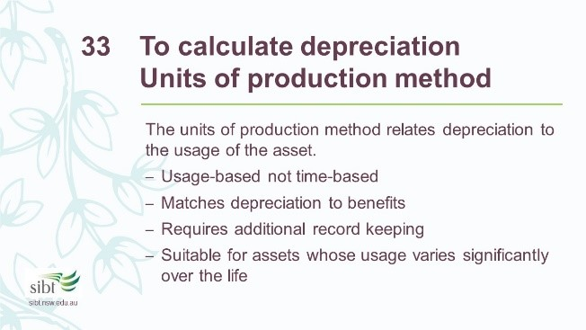

Cost−scrap value

Depreciation Cost per unit =

useful life in units

Depreciation expense= depreciation cost per unit ∗ units produced

|  |  |
| --- | --- |
| **Exercise 8.6** | Depreciation Method 3 – Units of Production |

For the same ribbon printing machine. Adele has decided to use the units of production method to calculate depreciation. The scrap value stays the same. Adele estimates that the machine can process 1,800 metres of ribbon during its useful life. And she plans to use the machine according to the following plan per financial year:

|  |  |  |  |  |  |
| --- | --- | --- | --- | --- | --- |
| 2016-17 | 2017-18 | 2018-19 | 2019-20 | 2020-21 | 2021-22 |
| 200 metres | 450 metres | 200 metres | 350 metres | 450 metres | 150 metres |

1. Calculate the depreciation per metre:

|  |
| --- |
| Depreciation cost per unit ==0.5 per metre produced |

1. Complete the depreciation schedule:

|  |  |  |  |  |
| --- | --- | --- | --- | --- |
|  | **Beginning carrying value** | **Depreciation** | **Year-end carrying value** | **Accumulated depreciation** |
| Year 1 ended 30/06/17 |  |  |  |  |
| Year 2 ended 30/06/18 |  |  |  |  |
| Year 3 ended 30/06/19 |  |  |  |  |
| Year 4 ended 30/06/20 |  |  |  |  |
| Year 5 ended 30/06/21 |  |  |  |  |
| Year 6 ended 30/06/22 |  |  |  |  |
| Total depreciation |  |  |  |  |

1. Prepare the adjusting entry on the 30 Jun 2017:

|  |  |  |  |
| --- | --- | --- | --- |
|  | **General Journal** |  |  |
| **Date** | **Details** | **Debits** | **Credits** |
| 30 Jun 17 | Depreciation Expense – Equipment | 100 |  |
|  | Accumulated Depreciation –  Equipment |  | 100 |
|  | (To record depreciation expense) |  |  |

### D. Comparing the 3 depreciation methods

Different depreciation methods allocate different annual depreciation expense. This leads to different influences on profit.

No matter which method is used, an asset’s total depreciation amount over its’ life will be the same.

Total depreciation = Acquisition cost−Scrap value

In practice, the straight-line method is the **most commonly used** method because it is easy to apply.

The **diminishing balance method** leads to more depreciation expense during the early periods of an asset’s useful life. The combination of decreasing depreciation and increasing repair and maintenance expense tends to equalise the total periodic expense of the asset and achieves profit smoothing.

The **‘units of production’ method** provides a more accurate measure of deprecation by matching the depreciation expense to the output.